Assignment 3

IP Interfaces: Part 2

By Ziming Song

[zs2815@nyu.edu](mailto:zs2815@nyu.edu)

|  |  |  |  |  |
| --- | --- | --- | --- | --- |
| VM (interface) | IP Address | Network Address | Broadcast Address | Range (usable addresses) |
| R2 (eth1) | 10.10.11.1/30 | 10.10.11.0/30 | 10.10.11.3/30 | 10.10.11.1/30-10.10.11.2/30 |
| R3 (eth0) | 10.10.11.2/30 |
| R2 (eth2) | 10.10.11.5/30 | 10.10.11.4/30 | 10.10.11.7/30 | 10.10.11.5/30-10.10.11.6/30 |
| R4 (eth1) | 10.10.11.6/30 |
| R3 (eth1) | 10.10.11.9/30 | 10.10.11.8/30 | 10.10.11.11/30 | 10.10.11.9/30-10.10.11.10/30 |
| R4 (eth0) | 10.10.11.10/30 |
| R4 (eth2) | 10.10.11.17/28 | 10.10.11.16/28 | 10.10.11.31/28 | 10.10.11.17/28-10.10.11.30/28 |

# **Part 1: Configuring Network Interfaces**

Screenshot of the .conf file under /etc/frr/frr.conf from R2, R3, and R4:

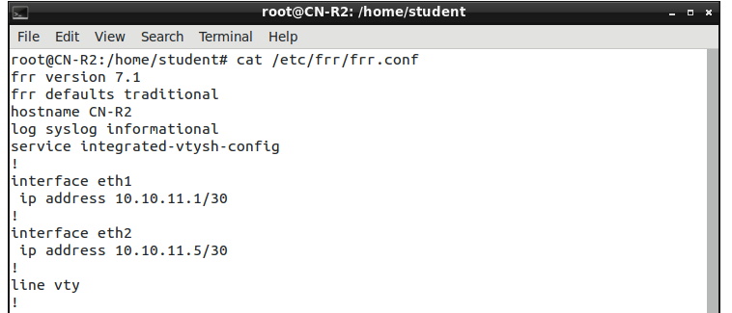

Screenshot of the .conf file under /etc/frr/frr.conf from R2

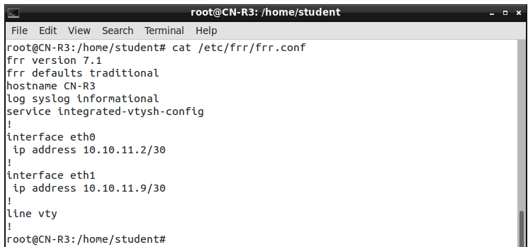

Screenshot of the .conf file under /etc/frr/frr.conf from R3

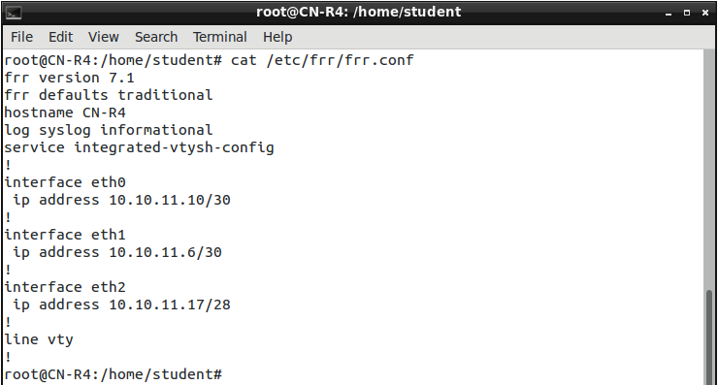

Screenshot of the .conf file under /etc/frr/frr.conf from R4

Address of R2,R3 and R4:

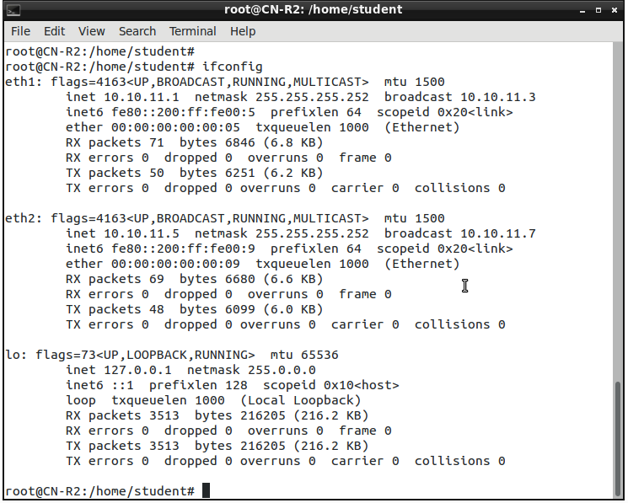

Screenshot of address of R2

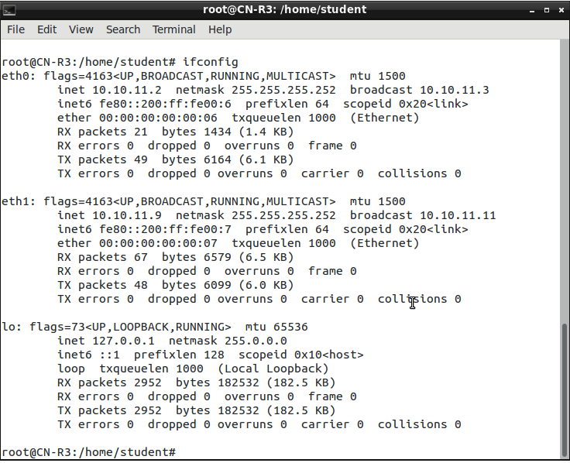

Screenshot of address of R3

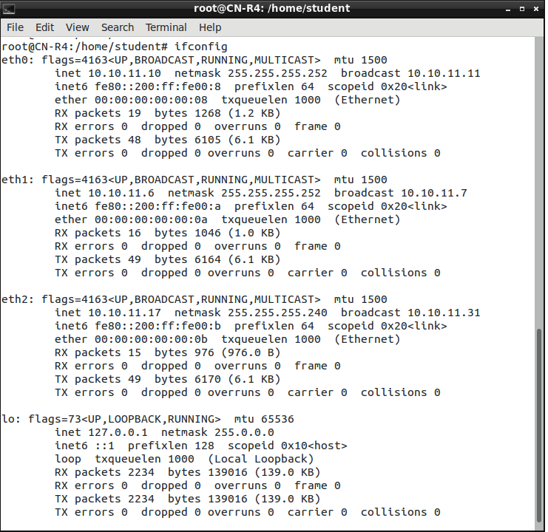

Screenshot of address of R4

Ping between R2,R3 and R4:

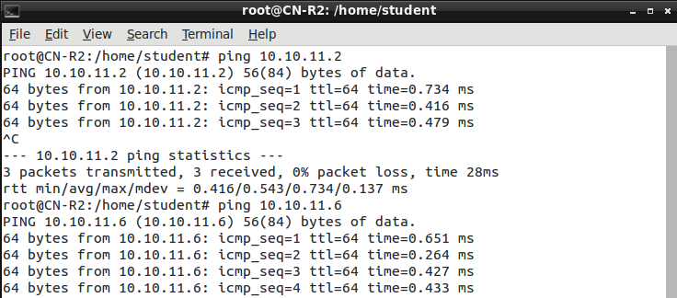

R2 to R4

R2 to R3

Screenshot of ping R2 to R3,R4

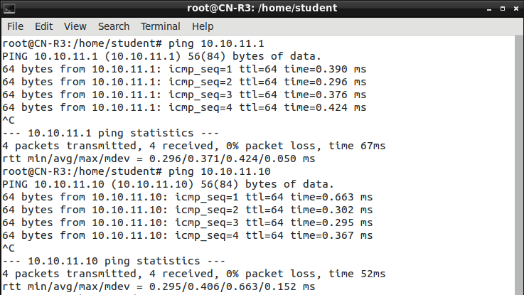

R3 to R2

R3 to R4

Screenshot of ping R3 to R2,R4

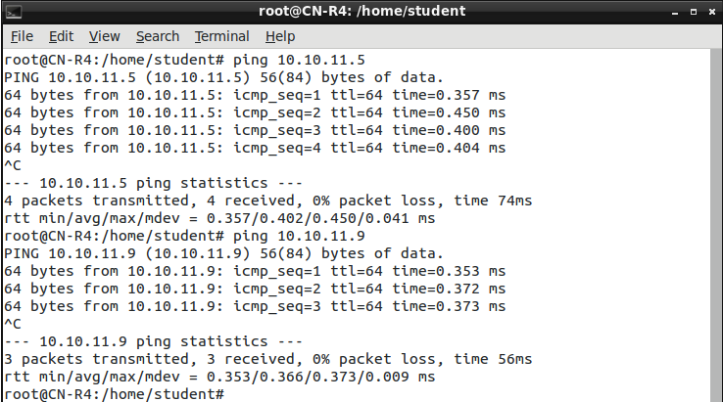

R4 to R3

R4 to R2

Screenshot of ping R4 to R2,R3

ARP tables on R2, R3, and R4:

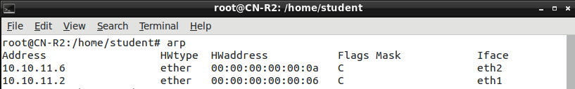

ARP table of R2

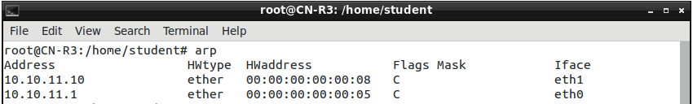

ARP table of R3

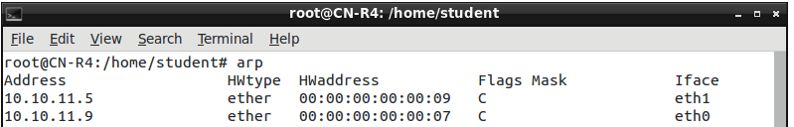

ARP table of R4

# **Part 2: Questions**

## **Why must we ensure that our subnets do not overlap? Discuss one example of something that could go wrong.**

Because

(1). Subnets overlap can lead to IP address conflicts and routing ambiguity. A device may receive conflicting routing information and may not know which subnet to use.

(2). Subnets overlap will lead to security vulnerabilities. Devices in one subnet may unintentionally communicate with devices in another subnet, potentially

leaking information.

(3). Subnets overlap wastes address.

Example:

Subnet A: 10.10.11.0/30

Subnet B: 10.10.11.0/30

In this scenario, both A and B have been assigned the same subnet, which is an overlap.

Devices in both A and B may be assigned IP addresses 10.10.11.1. When a device in A, for instance, tries to communicate with 10.10.11.1, the network does not know whether to route it to A or B, leading to IP address conflicts and communication issues.

## **Suppose there is another Router (R5) directly connected to the HUB between R3 and R4. Explain whether or not we would need to reconfigure the IP subnets on R3 and R4 in order to communicate with R5.**

We don’t need to reconfigure.

R3 and R4 are in the same subnet 10.10.11.8/30. R5 is directly connected to the HUB between R3 and R4, it should also be assigned an IP address within the same subnet for them to communicate. We could assign R5 the IP address 10.10.11.11/30, which is the next available address in the subnet after R4's address. And 10.10.11.12/30 can become the broadcast address.

## **Run Wireshark on R2 (eth1). Now ping R3(eth1) from R2. Identify what type of packet is used in ping. Why is R2 unable to reach R3 (eth1)?**

When ping R3(eth0) from R2, we can see the type of packet is used in ping is ICMP.

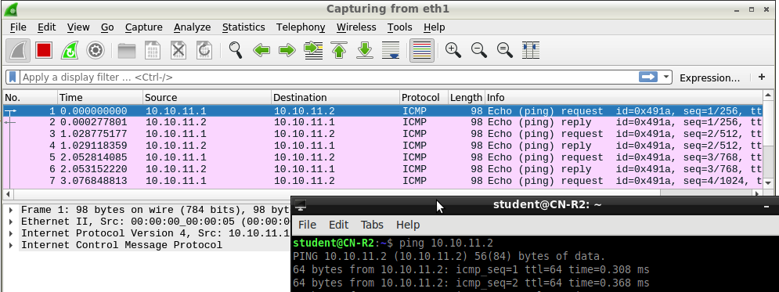

Screenshot of Wireshark result of pinging R3(eth0) from R2

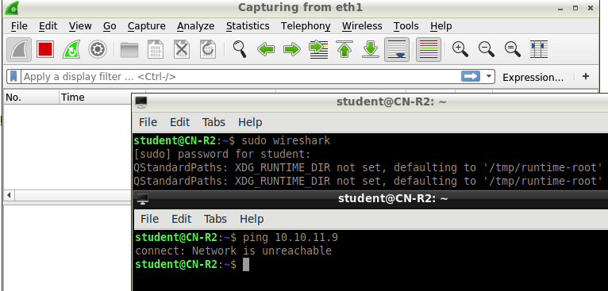

Screenshot of R2 unable to reach R3 (eth1)

R2 unable to reach R3 (eth1) because R3 (eth1) is neither in the same subnet of R2(eth1) nor R2(eth2).

## **Briefly describe how Wireshark results compare when you ping R3 (eth0) from R2 (eth1).**

(1). ICMP Echo Request packets originating from R2 (eth1) with a source IP address of R2's eth1 interface(10.10.11.1) and a destination IP address of R3's eth0 interface(10.10.11.2).

(2). In response to the ICMP Echo Request packets, R3(eth0) send ICMP Echo Reply packets back to R2(eth1) with a source IP address of R3's eth0 interface(10.10.11.2) and a destination IP address of R2's eth1 interface(10.10.11.1).

In both(1)(2), Ethernet frame headers for each packet shows source and destination MAC addresses, as well as other Ethernet-specific information. The MAC addresses correspond to the interfaces of R2 (eth1) and R3 (eth0) involved in the communication, ensure them transfer correctly. Timestamps and packet details are also given by Wireshark.